Title: | Applied Information Technology 2a & 2b  
Task/Lesson No. | Task 3 Equipping an office
Type: | Investigative Report
Outcomes | Outcome 2: Understanding ICT; Outcome 4: ICT in Society
CONTENT: | Media Information Communication and Technology
Class: | AIT 2a 2009
Area: | Technology & Enterprise
Teacher: | Mr Faulks
Phone:
Contact email:
Timeline: | 3 – 4 weeks
Date Due: | 3 weeks Term 3
Task Notes:

UNIT: 2AAIT
TASK 4: Equipping an office (100 marks) 20%
Task
3

Brief: Stuart Edwards has decided to set up a small desktop publishing business and has leased a small shop unit in a light industrial area. The floor plan of the unit is shown below (not to scale).
10 m, Brick except for window
6m, All Glass
2m

2.5 m
5m, All Brick

6.5 m, All Glass

N

Shopping Precinct

Stuart plans to produce the following from this unit:
- Black & white leaflets and flyers
- Colour leaflets and flyers
- Business cards
- Colour brochures (A4, 3-panel etc.)
- Commercial Web Sites - Designs

Scenario: At first Stuart ran his business from home by himself whilst employing a part-time receptionist / secretary. He has now purchased the above office and he now produces commercial websites. He has expanded from one web author (himself) to a business employing 3 designers, a receptionist/secretary and a computer technician.

You are required to investigate what new equipment they need to purchase to fully equip the office including wireless networking for all staff.

You need to investigate avenues of training for the designers and IT technician.

You will need to also produce a plan of how the office layout should look and indicate where computers and desks should be established – keeping in mind ergonomic requirements

Your Task

    - Use a graphics package to make a copy of the diagram above (use most of one page).

- Now use the graphics package to place the furniture that you think Stuart should have to run his business.

- Make sure that the diagram is clearly labelled, Add walls if you wish and also place any computer hardware that is required.
20 marks

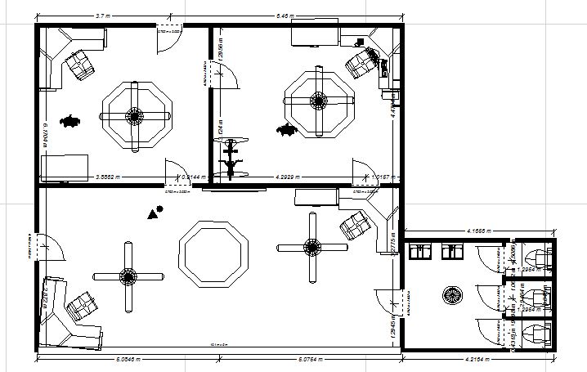
    - Include on this document a list of the hardware items that you have included and a brief description of what the item is, (computer, scanner, printer etc.) what it is used for and why you put it where it is.
Answer:

15 marks
You would use, desks, chairs, monitors, modem, desktop computers for every office member, photo copiers, scanner, printers, Fans, toilets etc

    - Include software that you would recommend for this business.
Answer:

I would recommend Microsoft Office; it includes all the basic programs for an office like excel word etc. 10 marks

    - Also include on this document a list of ergonomic requirements that need to be addressed in an office environment
Answer: Work stations should be designed to be suited to several tasks, such as, screen work, keyboard inputting, writing etc. Work chairs should be made for office use and supportive of posture and back. Exercise equipment is also recommended for the wellbeing of the office workers, even a pool table.

TYPE: Investigation

Time allocation
Four weeks

What you need to do
- Investigate computer systems needed for website developers (hardware and software).
Obtain prices for the machine you have specified

- What sort of infrastructure would a web site development business need?
Include ergonomic workstations, networking the computers, communications with clients

- List any security issues that the business would need to consider. Include physical security, security of data, and security against malicious software

- Training of website developers and technician
Describe the job description and the training needed for the designers and the technician include the general salary range

- Report format
Your document should have the following:
- cover page
- table of contents
- references
- correct formatting
- headers and footers
- appropriate graphics
- office re-designed
- training requirements
- hardware
- software
- ergonomic considerations
- evaluation

What needs to be submitted | Due date
- Report (Any suitable format – Power Point – In-Design or Word)
- office re-designed
- training requirements
- hardware
- software
- ergonomic considerations
- evaluation
MARKING KEY UNIT 2AAIT

Student Name

Task 4: Equipping an office Total: 100 marks

Items | Possible  mark | Actual  mark
Section 1 Computer system | 30
Hardware specifications | 20
Software & Prices | 10
Section 2 Infrastructure | 30
Re- Design of Office - Workstations etc. | 10
Network configurations Staff and Client communication | 10
Ergonomic Considerations | 10
Section 3 Security | 10
Physical security & Malicious software | 5
Data security | 5
Section 4 Training | 10
Job description of both | 5
Training of both | 5
Section 4 Formatted report | 20
Referencing of all sources used | 5
Report is correctly formatted | 5
Cover page Table of contents | 5
Headers/footers Graphics | 5
Total | 100

Teacher comment:

Evaluation Individual Task 3

Task Number

Your Name Date

You have been working on a task. Part of your task is to honestly evaluate your own performance. This evaluation will assist in the determination of some of the course outcomes. It is a confidential evaluation and only Mr Faulks will read it.

Name: <type or write here>

Task: <type or write here>

List down all the aspects that you have completed during the task
i.e. Investigating, Devising, Producing etc.
<type or write here>

List down any of the new skills you have learnt while undertaking this task.
<type or write here>

What are some things you have found out about yourself while investigation this task (e.g. – I didn’t know I had such good leadership qualities, I always need someone to keep me on task)
<type or write here>

Reflect on the process that you have gone through since commencing your investigation of this task, write about any successes or problems you have personally encountered.
<type or write here>

Do you consider yourself to be a consistent worker (eg will be on task for most of the week). Why? Why Not? Give examples where appropriate.
<type or write here>

Do you think your application to the task has improved your planning skills? Why? Why Not? Give examples where appropriate
<type or write here>

Rate yourself 0 to 10 on the following criteria (10 being excellent)

Ability to locate information & research without any assistance

Shows initiative

Leadership Qualities

Application to the task

Time Management

Works without any ‘nagging’ from the teacher

Did you personally enjoy investigation of this task
Yes / No Why: <type or write here>

What are some things you liked about this task?
<type or write here>

What are some things you disliked about this task?
<type or write here>

The course requires you to think a lot for yourself and to find out your own information, did you find this type of environment an enjoyable one to work in, or do you prefer the teacher up the front of the class teaching the information and then getting tested on it?
Please comment.
<type or write here>

Any other comments you would like to make?

<type or write here>

Save your evaluations as (your initials)_task_eval into your folder, attach it to the web link site or email it to me before the end of the week.

